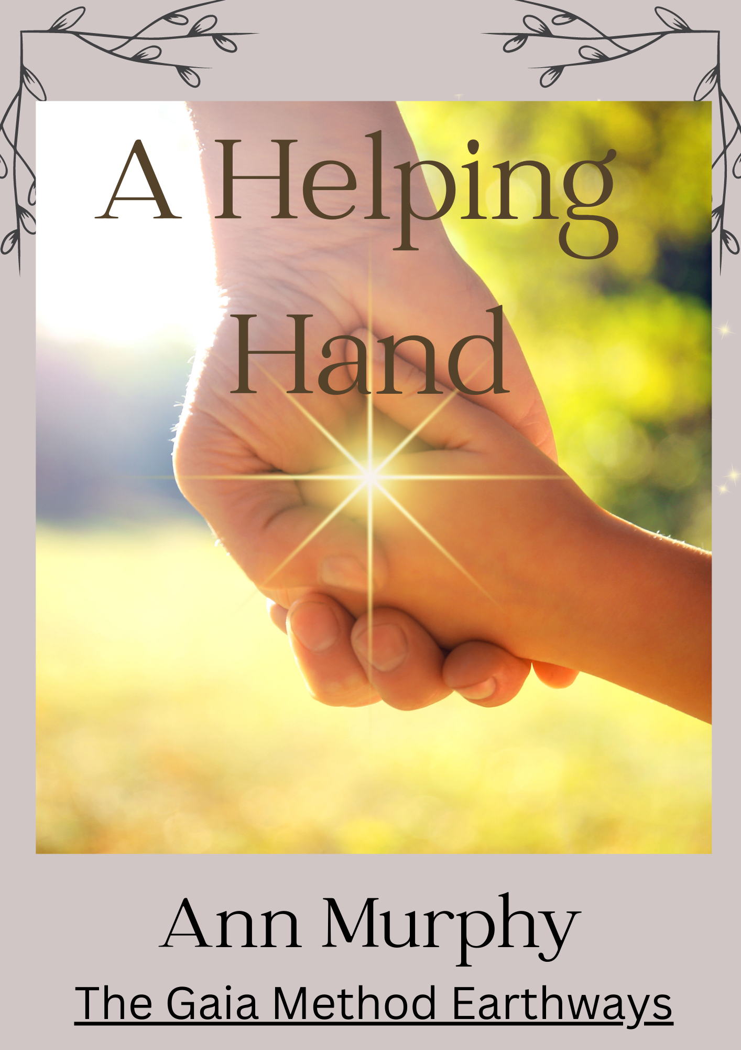

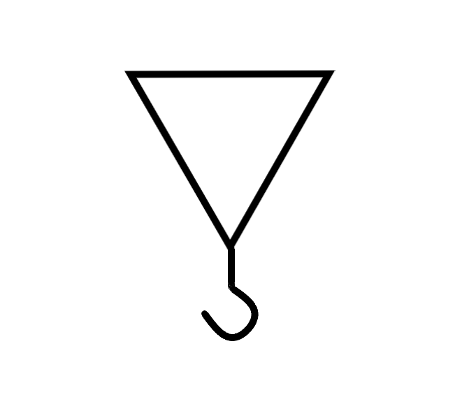
This symbol is called A helping Hand, or a hand-up.
I received this symbol when I was struggling with a relationship issue that had its roots in a past life. Deep in the emotional layers of this old dynamic, which had been playing itself out for most of my current life, I obviously needed some help.
While doing a meditation to connect with my Soul and the upper levels of my energy-field, intending to gain more understanding of how the dynamic needed to be healed, I was given this symbol. The image appeared above my head, and I recognised it as one I had received before, but had not understood its meaning so promptly forgot all about it. This time, however, my guides wanted me to understand the meaning, so it could be used intentionally.
The inverted triangle represents the upper levels of consciousness, the levels of guides/angels/spirit/your Higher Self, etc. It is inverted because the energies are reaching down to the physical layers from a more expanded state of consciousness. This expanded state is the energy of Soul-love and higher understanding. It removes the energy of powerlessness in the situation and reminds us of the higher purpose of the relationship, even if that is not a conscious remembrance. The image that came with the symbol was of a father reaching down to hold the hand of his child. (Symbols usually have a visual component which explains the use of the symbol. It could equally have been a woman’s hand, but as my guide is male, I imagine this is why it came in this way).

This symbol does not help you avoid the emotional healing, but helps you to not get stuck in the blame game. It helps you maintain unconditional love for the person while still releasing the stuck and painful energies of the past. This works well if there is a deep bond with the person, such as a family member, or close personal relationship, etc. However, as with all healing, there must be a readiness to see another person with unconditional love. If you are in a damaging relationship, it is more difficult to see with unconditional love and survival may be more important. Often, the ability to see the other person as a co-creator comes later and after much healing and therapy. But when you have healed, or let go of someone, or you are in healing dynamic and old issues come up, then is a good time to use it.

The hook on the end of the triangle is the hand, that which holds. It is like a winch that we can grab hold of when we need to be pulled out of a sticky situation, or at least pulled out of the trickier aspects, if we feel bogged down. It is a reassuring energy and one we can call on when we need extra energetic help.
If you find yourself in an emotional situation and need to stay centred, or you want to become unstuck, then meditate on this symbol. It helps if you visualise, or intend, both the symbol and the image of the adult’s hand reaching down to you, offering its help, pulling you out of old dense energies.

Another use of the symbol is for when you need to raise your consciousness to a higher level while moving through healing. If you do healing, or any other kind of energetic work, such as readings, etc., and you are experiencing a release of emotional energies yourself, it can be a challenge to rise above the denser emotional energies to connect with your guides or Soul. But by using this symbol, you are given a helping hand so you can work and heal at the same time, something I was never able to do in the past. In fact, I really could have used this back then when I found it nearly impossible to do anything ‘normal’ while going through deep healing.

Creative blocks.

After creating this short meditation, my guides then shared another use for the symbol, this time using it for white dragon inspiration.
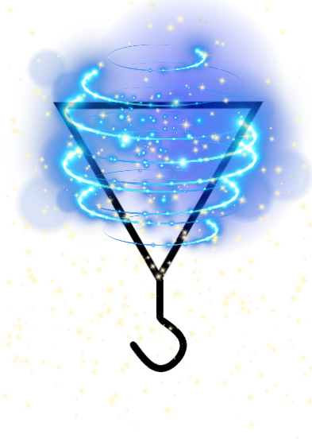

The addition of the white dragon vortex is to get you unstuck and out of a creative rut. If you need inspiration, especially when involved in a creative endeavour that is inspired by higher consciousness, then try meditating with this version. It should get the creative juices flowing again.
This also works when, just as in the healing process, you have to work when you are feeling emotionally blocked.

Try using the energy and see what happens. And remember to keep a record; you might need it one day.

